Supplementary material

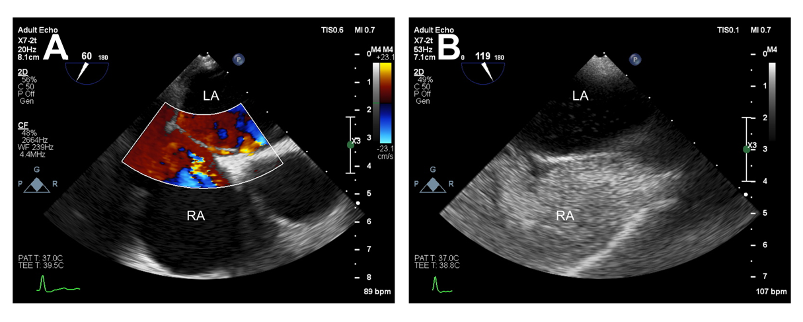
Supplementary Fig. 1. The presence of PFO was confirmed when the PFO channel was directly visualized by color Doppler imaging (A) or when microbubbles entered the left atrium from the right atrium within three cardiac cycles in right atrial visualization after injecting oscillating saline (B). Abbreviations: PFO, patent foramen ovale.

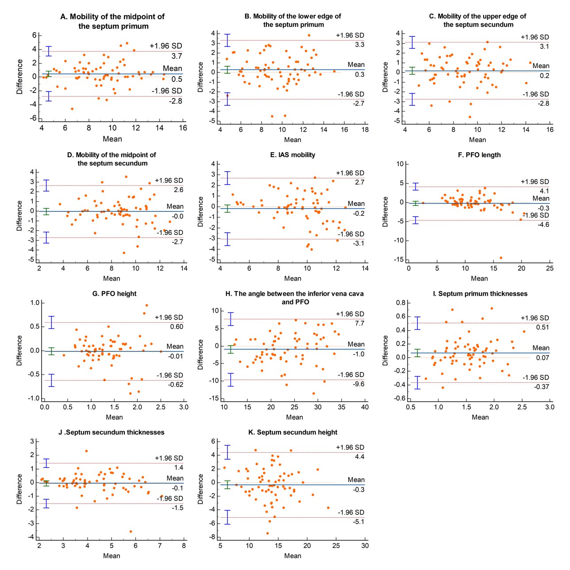
Supplementary Fig. 2. Bland-Altman plots comparing the measurements performed by two independent researchers.

Supplementary Table 1. Assessment of interobserver and intraobserver variability.
 | Interobserver (n = 68) |  | Intraobserver (n = 20)
Parameters | ICC | 95% CI | ICC | 95% CI
Mobility of the midpoint of the primary septum, mm | 0.778 | (0.657–0.859) | 0.838 | (0.532–0.94)
Mobility of the lower edge of the primary septum, mm | 0.820 | (0.725–0.885) | 0.828 | (0.61–0.928)
Mobility of the upper edge of the secondary septum, mm | 0.799 | (0.693–0.871) | 0.802 | (0.569–0.917)
Mobility of the midpoint of the secondary septal, mm | 0.812 | (0.712–0.88) | 0.835 | (0.631–0.931)
IAS mobility, mm | 0.738 | (0.608–0.83) | 0.743 | (0.462–0.889)
PFO length, mm | 0.824 | (0.73–0.887) | 0.766 | (0.498–0.9)
PFO height, mm | 0.8 | (0.695–0.872) | 0.881 | (0.636–0.957)
Angle between IVC and PFO, degrees | 0.728 | (0.593–0.823) | 0.774 | (0.511–0.904)
Septum primum thickness, mm | 0.846 | (0.752–0.904) | 0.906 | (0.782–0.962)
Septum secundum thickness, mm | 0.821 | (0.725–0.885) | 0.907 | (0.782–0.962)
Septum secundum height, mm | 0.759 | (0.638–0.844) | 0.848 | (0.655–0.937)

